Shadow = digital imprint of who you are

GOOGLE

|  |
| --- |
| * Reanimator |

“Accidental Death”

Perspective

Aliens Mesopotamia 🡨 Annunachi?

To mine gold

Only Rule

|  |
| --- |
| No Mixing of Breeds |

Big Ass Canvas to gin.

Rufi = Good alien

Lost wife and son in war ☹

Good and pure alien 🡪

Clones / Re-animation 🡪

Oops 😐

Hybrids

Roofie🡪

Claira 🡪

Wife?!

No ☹ 🡪

Rufi rapes Claire (clone)

Rape/ pregs

Seth (Real son)

Kills cloned Mom To Help

|  |
| --- |
| Big event??? |

Eh-body flees!

|  |
| --- |
| (Exodus) |

Aliens aware 🡪

(but 0 son)

LINK

Broke

Apple ☹

*----------------------* *----------------------*

Sassy Prophet Jr.

Noah

-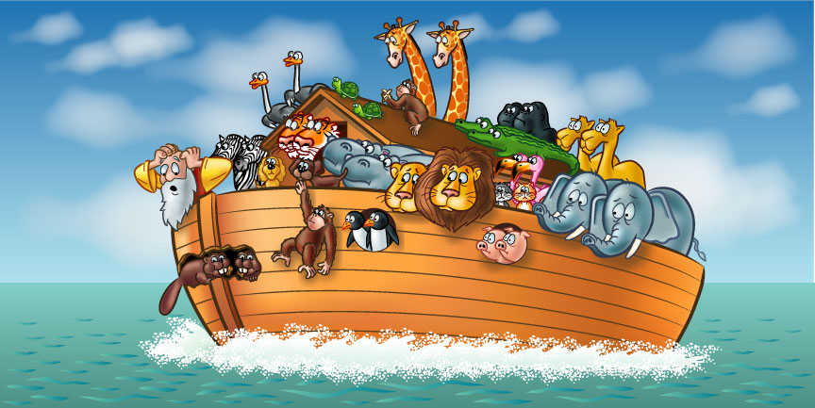

~ NOW!

~ 1,00’s of peeps

Seth’s clone and Clara together

She doesn’t know it was her son

Pro creation

Still 100+ aliens in safe “natural energy” places 🡪

They promised

It returned.

Good aliens

Rogue aliens (by choice)

Attack

Stay with humans love/ lust?

Went Back

Safety Safe

Time released raid thing

Virus and plague

Meteors, Hail and Brimstone

Famine / Disease / Sterility = toxins / poisons

< EVOLUTION >

☺

Seth’s Clone and Clara ♥

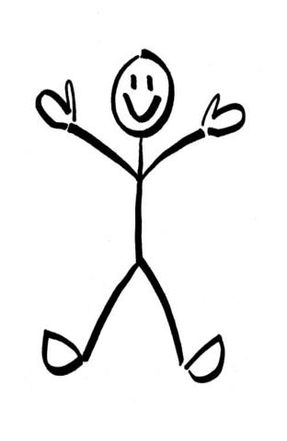

We are here now.

“The things of knowing”

Government

Human Mules

|  |
| --- |
| Government Mules |

🡨 ♪♪♪  
Alien Missionaries

Secret Societies

Gardens

Beauty

Gold

Destruction

Aliens

Rufi =

Public figure on news

80 Clara (real mom)

Can’t tell

A/B real rapey guy

To protect them

Trystan and Krystan – Twin boys

*

< ? Joseph Campbell? >



Who Are We?

Regular humans

?

(Realize they aren’t)

After age 33

(Jesus dying?)

12

Krystal & Trystan

Krystal – Hidden.

Arc of Covenant

Behind the veil

The Precious

Trystan – Vigilante / Anarchist

Poet

Motorcycle riding

Fountain of Youth

Charging Mat

Crystals

<Rufi & Seth>

Tristan 1/2

Ezekiel (Zeke)

Humanity must destroy Rufi’s rapist regime

8

(Alien)-ated

*------------*

Wake up!

Rufi (bad) = Hitler, Manson, Jim Jones EVIL!!!

|  |
| --- |
| The Hunger |

And den…

Earth

🡨 particle

What happens when we return in another 6,000 years?

2014

+ 6000

--------------------  
 8014

*----------------------------------------------------------*

Snippet:

Trystan 🡪 Ambushed and interrogated about his brother’s whereabouts

Rufi – Believed only son survived

-- Set

Knowledge

Realization

|  |
| --- |
| Kristin |

Snaps out to save his brother

----------------------